2019

Metrom Rail

11/27/2019

AURA Train Control Systems

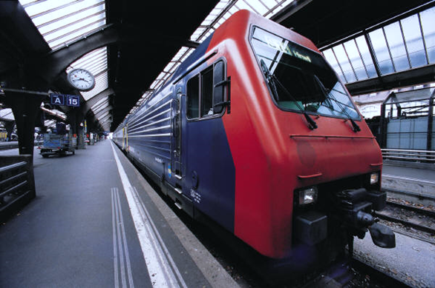

Table of Contents

How UWB Works 1

**Conventional Radio Ranging** 1

**UWB Radio Ranging** 2

Types of Systems 3

**ATP Overlay Configuration** 3

**ATP System Configuration** 4

**ATO System Configuration** 5

How Metrom Rail Uses UWB 6

**How Train Location, Speed, Direction, and Consist Length are Determined** 6

**Ranging Advantages** 6

**Worker Protection** 6

System Features 7

**End-of-Line (EOL) Beacon** 7

**Precision Berthing** 7

**Signal Enforcement with ATP Overlay Configuration** 7

**Signal Enforcement with ATP or ATO Configuration** 9

**Overspeed Enforcement with ATP Overlay Configuration** 10

**Overspeed Enforcement with ATP or ATO Configuration** 10

**Improperly Lined Switch Protection with ATP or ATO Configuration** 10

**Train-to-Train Collision Avoidance with ATP Overlay Configuration** 10

**Train-to-Train Collision Avoidance with ATP or ATO Configuration** 11

**Automatic Train Operation (ATO)** 12

Installation Advantages 12

Transmission Security 13

Safety Strategy 13

**Compliance with EN and SIL4 Standards** 13

**Applicable Standards** 13

**Safety Level** 14

Technical Specifications 15

**Environmental Specifications** 15

**Temperature, Humidity, Shock, and Vibration Specifications** 15

**ESD/EMI/EMC Specifications** 15

**Abrasive Environment Specifications** 15

**System Characteristics** 15

Definitions and Abbreviations 16

**Introduction**

Since 2012, US-based Metrom Rail has installed over 5,000 ultra-wide band (UWB)-based collision avoidance systems (CASs) throughout North America with demonstrated operational success, accumulating over 17 million track miles over this time period. Between 2014 and 2017, Metrom Rail filed three patents for new technology in collision avoidance and vehicle management. Two of the patents are for CASs using transponder modules with UWB and radio communication units to reliably track speed and location of vehicles and distance between vehicles over a wide variety of tracks and terrains. The third patent institutes a vehicle management system which uses both a control signal interface and a vehicle-mounted system fitted with UWB communications components to determine the distance between the vehicle and the control signal interface and, if necessary, control the vehicle’s braking system to avoid a collision. Metrom Rail’s vast experience using UWB technology along with its innovative patents establishes them as the rail industry leader in UWB radio technology for communication-based train control.

Metrom Rail’s AURA System deploys UWB radio frequency (RF) to provide unmatched time-of-flight precision. UWB capability allows AURA to identify the exact position of a train relative to its position within the system and its distance from other trains, signals, or work zones. What sets AURA apart from other RF systems is its incredible accuracy and reliability, particularly in subways. Additionally, AURA provides a high degree of security due to the incredible difficulty of isolating UWB frequencies from the natural RF background noise. AURA is a modular system, allowing complimentary expansion of the base components to further increase the capabilities of the system.

**How UWB Works**

**Conventional Radio Ranging**

A lot of different methods exist for using RF technology to take measurements. The methods vary in usefulness across applications, however. For example, the conventional radio ranging methods that are extremely reliable for air traffic control have limited use in railroad applications due to the different complexities of the railroad environment.

The example below shows an ideal conventional ranging operation using a narrow band (single frequency) scenario. Radio A requests a range measurement, and Radio B sends a radio wave response. Radio A measures the time of flight (TOF) of the radio wave response, and that time is used to calculate the distance between Radios A and B.

**(Speed of light) ft/s x (time of flight) s = (distance A-B) ft**

In this example, a wall is shown on both sides of the radios as if the train were in a tunnel. The same principle applies to other objects in the environment, such as buildings, trains, or trees.

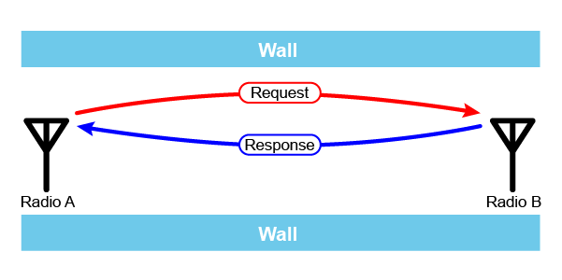

In real world applications, however, the radio waves bounce off of objects in the environment, thereby interacting with each other when they reach the receiving radio. This interaction can make the signal stronger, weaker, or it can completely cancel out the signals. This behavior is known as “multipath interference” or “constructive and destructive interference.”

In the example below, Responses 1 and 3 can destructively interfere with each other so that only Response 2 is received, giving a range measurement that is greater than the actual range value. This interaction makes narrow band radio signals unsuitable for distance measurements in environments with multipath interference, such as railroads and subways, since there is no way to ensure the accuracy of the measurement.

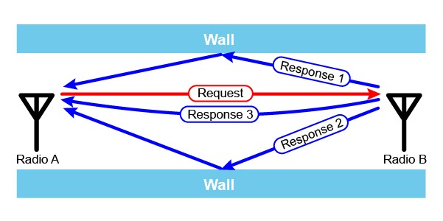

**UWB Radio Ranging**

By contrast, UWB technology uses extremely accurate clocks and very short radio wave pulses (six inches long) on many different frequencies to overcome the problems of narrow TOF distance measurements. The UWB ranging method has a much smaller train location uncertainty level than conventional radio ranging because the method of measurement is far more accurate and updates occur far more frequently, with absolute location being determined three times per second.

In the simple example below, a range request from UWB Radio A triggers thousands of radio wave pulse responses that are transmitted across a larger frequency band by UWB Radio B. Some pulses at certain frequencies are cancelled by reflected pulses due to the particular environment (destructive interference). Radio A uses an accurate clock to measure the TOF of the response pulses and then compares all the resulting distance measurements. Pulses that arrive by an indirect path due to bouncing around in the environment and therefore traveled a distance of at least 6 inches greater than the shortest path signals are rejected because they arrive too late to be accepted in the final accurate distance measurement. In this example, only responses R3 and R4 are used to make the final distance measurement. Additional pulse signal conditioning and filtering algorithms are used to increase the resolution, accuracy, and reliability of the measurement

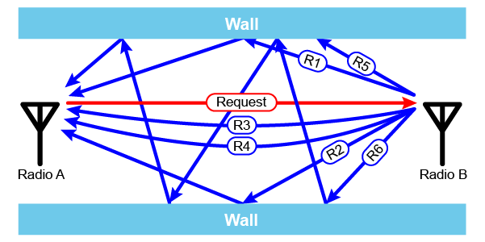

**Types of Systems**

The AURA System is a UWB train-centric train control system. It is a scalable solution that can be deployed as an overlay to an existing signal system, as an Automatic Train Protection (ATP) system, or as a complete Automatic Train Operation (ATO) system. The different implementations use modular components, allowing an overlay system to later be upgraded to an ATP system and an ATP system to be upgraded to at ATO system by simply adding or upgrading existing hardware.

The ATP overlay system configuration can be implemented with minimum infrastructure to reduce installation costs while providing the basic features. Because the system does not require many of the hardware elements found in conventional train control systems, it reduces both costs and installation complexity. The system equipment is all installed on either the vehicle or on the wayside.

**ATP Overlay Configuration**

The AURA System in the ATP overlay configuration is comprised of:

* **Smart Signal—**Includes integrated UWB and 2.4 GHz radios and the associated power supply, and it is configurable to agency requirements. The Smart Signal replaces the existing signal, and the power supply for the signal also supplies the integrated UWB and 2.4 GHz radios. This integration eliminates the costly installation of new AC or DC power lines to wayside locations.
* **Carborne Controller—**A redundant device that includes vital and non-vital processing, train system interfaces, brake interface, and train operator display interface. One unit is installed in each train control cab.
* **Wheel Encoder and Interface**—Configurable based on the vehicle. If an encoder signal is available for use on the vehicle, then that signal can be used. Otherwise, a separate wheel encoder is installed on the vehicle.
* **Carborne UWB Ranging Radios**—UWB radios that perform the radio ranging to the Smart Signals.
* **Carborne 2.4 GHz Data Radio—**Provides data communication between the Smart Signal and the carborne controller.
* **Carborne RFID Reader—**Provides diversity of train localization data.
* **Carborne Train Operator Display**—Displays warning messages to the operator.
* **RFID Tags**—Used in conjunction with the carborne RFID reader.

**ATP System Configuration**

The Automatic Train Protection (ATP) system configuration provides signal enforcement, overspeed enforcement, and improper line switch protection functionality. The system includes capabilities to add optional hardware such as an Automatic Train Supervisor to increase functionality. This configuration uses redundant hardware to ensure high system reliability and availably.

The AURA system in the ATP configuration is comprised of:

* **Wayside UWB Anchor Network**—Consists of UWB radio modules, or anchors, located on the right-of-way so a train traveling on the track is always in range of three anchors. Each anchor contains redundant UWB radios. The radios coordinate with the redundant carborne radios for UWB ranging. The anchors are connected to the wayside fiber optic network for maintenance and diagnostic purposes.
* **Wayside Backbone Communication Network (BCN)**—A combination of a mesh radio network and the wayside fiber optic network that provides data communication from the carborne controller to the wayside equipment. The BCN is fully redundant to ensure high availably and fault tolerance.
* **Wayside Fiber Optic Network**—Provides data communication between wayside and back office equipment. This network is fully redundant to ensure high availability and fault tolerance.
* **Carborne Controller—**Comprised of redundant A and B controllers, configured as a primary controller and a backup controller, to provide high system availability. The A and B controllers have independent and redundant UWB radios to provide high reliability train position measurements. Each controller uses 2 out of 2 processing for vital functions. Each controller includes vital and non-vital outputs to interface with train systems. One unit is installed in each train control cab.
* **Carborne Train Operator Display—**Displays warning messages and other information to the operator.
* **Wayside Message Interface (WMI)**—Receives vital information from wayside equipment and responds to requests for vital information from the carborne controller.
* **Wayside SSI Controller—**A vital device that monitors various wayside devices and sends vital communication of the device’s status to the WMI. The SSI Controller can also be configured to manage interlockings. One unit is installed at each interlocking, switch or signal.
* **Axle Counters and Interface—**The axle counter is used at switches and interlockings to provide the SSI Controller with track occupancy information. The axle counter interface is connected to the SSI Controller by Ethernet through the wayside fiber optic network.
* **Automatic Train Supervisor (ATS) Server (optional)—**Can be added to the system to aid in managing train scheduling.
* **ATS Workstation (optional)—**Provides the user interface to the ATS.
* **UWB Anchor Diagnostic Server (optional)—**Monitors the UWB anchor operation and runs diagnostic tests on anchor performance for preventive maintenance.

The illustration below shows an overview of the AURA System in the ATP configuration.

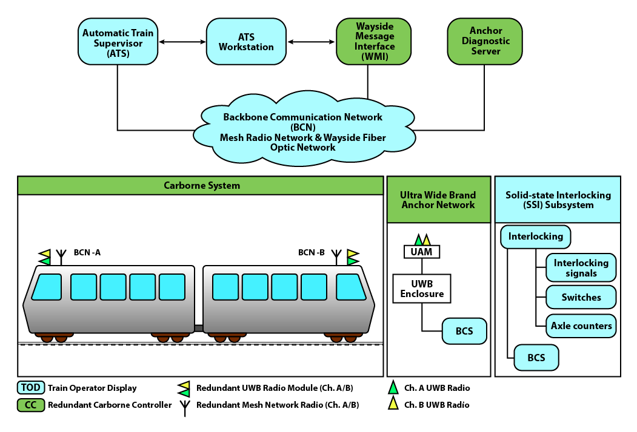

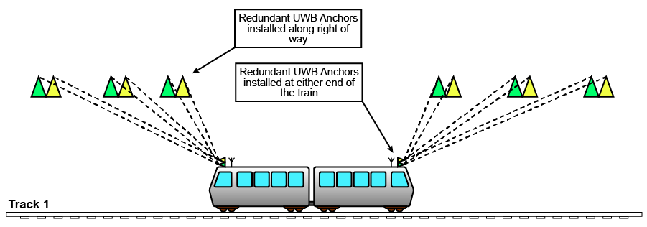The illustration below shows how a redundant UWB radio is used. UWB anchors are located on the right-of-way so the carborne controller at either end of the train is always in range of three UWB anchors. This ensures high availability and fault tolerance.

**ATO System Configuration**

The Automatic Train Operation (ATO) system configuration provides signal enforcement, overspeed enforcement, and improper line switch protection functionality with an Automatic Train Supervisor (ATS) to manage schedules and routes for ATO. ATO functionality includes door interlocking, precision station stopping, router interlocking, schedule management, and non-vital speed headway regulation. The ATO system configuration uses much of the same hardware as the ATP system configuration, allowing an ATP system to be easily upgraded to ATO by reusing the ATP system hardware.

The AURA system in the ATO system configuration is comprised of the same hardware as the ATP system configuration but includes the optional hardware.

**How Metrom Rail Uses UWB**

**How Train Location, Speed, Direction, and Consist Length are Determined**

The basic operating principle of the AURA System configuration is that the carborne controller gathers data from UWB ranging, the track map database, the wayside message interface via the BCN, and peer-to-peer connections to other carborne controllers and then performs vital processing onboard to provide ATP functionality. The carborne controller used in the AURA System handles the vital processing typically performed by the zone controller found in conventional Communications-Based Train Control (CBTC) systems. This architecture makes it easier to configure the system to a particular railroad environment.

In a conventional CBTC system, location updates are derived through wheel odometry (dead reckoning) and RFID tags. The CBTC system method has an inherent location uncertainty level due to wheel slippage that is only reduced when an RFID tag is scanned to accurately localize the train. Uncertainty can therefore grow to hundreds of feet before being corrected with an RFID tag scan.

By contrast, The AURA System uses UWB ranging to provide frequent, high accuracy absolute position updates to the carborne controller. The carborne controller communicates ranges to UWB anchors along the right-of-way and uses that data with the track map database to determine the location and speed of the train. This ranging method provides absolute position updates up to three times per second, offering absolute train position with low uncertainty. This higher accuracy of train location allows for more precise moving block train operation and higher system throughput.

**Ranging Advantages**

Conventional RFID train localization systems rely on RFID tags mounted on the track at specific locations. RFID tags are located in the hostile road bed environment and are subject to damage and vandalism. They also require physical inspection to ensure long-term reliability. RFID tag replacement can be complicated by overlapping responsibilities for procuring, programming, installing, testing, and approving a tag for use.

The AURA System’s UWB radio modules do not have any of the negative features of RFID tags. The modules are mounted on the right-of-way on a pole or on subway walls, which are less extreme environments and offer protection against vandalism. The radio modules are network-connected so they can be monitored remotely, which greatly reduces the need for physical inspections. UWB module replacement is simple. A maintainer replaces a module at a location with no preprogramming required. An authorized technician then activates the module remotely.

In the case of an RFID tag failure, the tag must be replaced before normal operation can resume. UWB radio modules are installed in redundantly so that a train on the right-of-way is always in range of multiple anchors. If a UWB modules fails, the carborne system switches to a redundant module with no effect on normal operation.

**Worker Protection**

The AURA Roadway Worker Protection System (RWPS) provides either a portable or a zone-based approach to giving warning to workers and operators of on-track equipment. The RWPS is the first worker warning system to take advantage of UWB technology, guaranteeing a reliable and precise speed- and distance-based platform that intelligently incorporates existing agency operating standards.

The AURA RWPS can operate as a standalone system or as an integral part of the AURA Train Control System. When used as part of the networked train control system, permanently installed nodes create overlapping work zones. Operators and workers receive alarms that must be confirmed when a train approaches an active work zone.

**System Features**

**End-of-Line (EOL) Beacon**

[I need more information here. I now understand that this allows the train to stop at the end of the line, but I need to know how the AURA System makes that work.]

**Precision Berthing**

The AURA System offers precision berthing which uses UWB to stop the train precisely at a station. When municipalities have platform screen doors that the train needs to line up with, precision berthing ensures precise alignment. Similarly, with “heavy rail” transit trains, where the platform is located several feet above the rail, precision berthing is critical for passenger safety. The AURA System ensures the train stops in the center of the platform boundary.

**Signal Enforcement with ATP Overlay Configuration**

When a train approaches a restrictive signal, it passes over the RFID tag, scanning the tag. The carborne controller uses the wheel encoder input and RFID tag scan to calibrate the approach distance to the signal. The train comes into range of the Smart Signal UWB radio and 2.4 GHz radio. The carborne controller interrogates the Smart Signal to obtain the signal status via the 2.4 GHz radio. The carborne controller uses UWB radio ranging to take range measurements between the train and the signal. The wheel encoder input is used as a redundant distance measurement input. The carborne controller calculates a safe braking distance (SBD) using an agency-approved safe braking model. The SBD is continually recalculated as the train approaches the signal. If the train operator attempts to violate the configurable SBD threshold, a warning countdown is displayed on the train operator display. If required, the carborne controller activates an emergency brake application. The following illustrations show how signal enforcement works using an RFID scan.

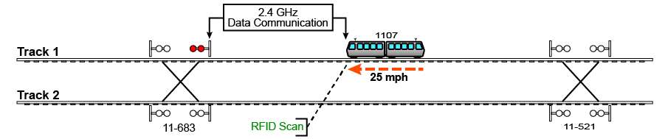

The following illustration shows how the SBD calculation is made.

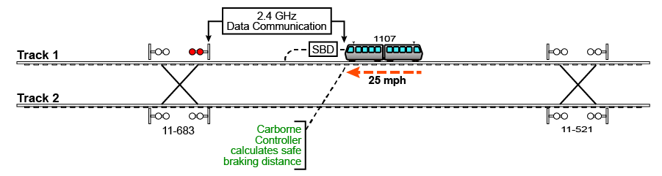

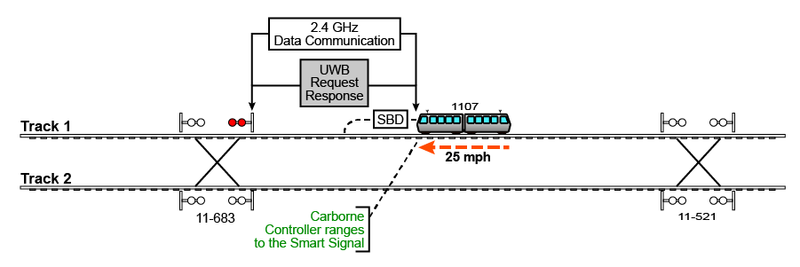The following illustration shows UWB ranging.

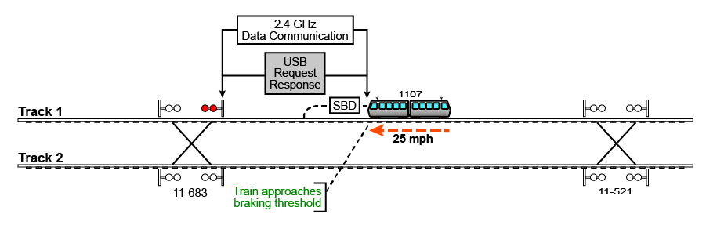The following illustration shows what happens when the train approaches the braking threshold.

The following illustration shows when the train operator display warning appears.

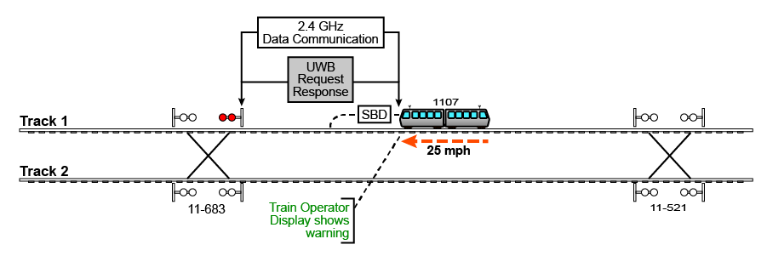

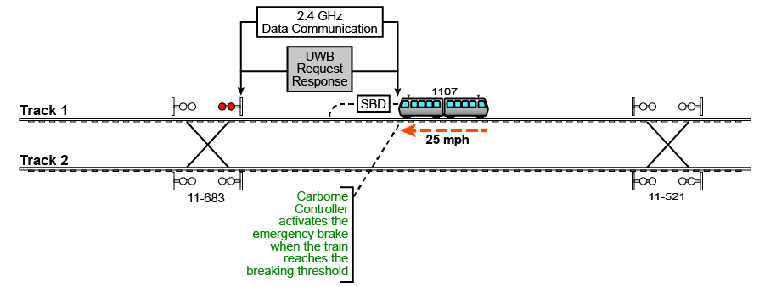The following illustration shows brake application.

**Signal Enforcement with ATP or ATO Configuration**

When a train is traveling down the track toward a restrictive signal, the carborne controller communicates ranges to UWB anchors along the right-of-way and uses that data along with the track map database to determine the location and speed of the train. At a configurable distance threshold from the signal, the carborne controller interrogates the wayside message interface to obtain the signal status. The carborne controller uses an approved safe braking model to calculate a safe braking distance (SBD). If the train operator reaches the configurable SBD threshold, a warning countdown is displayed on the train operator display. If the operator does not comply with the message on the display, the carborne controller activates the emergency brake.

In the illustration below, in an AURA System ATP configuration, Train 2401 uses UWB ranging to wayside UWB anchors and the carborne track database to determine its location and speed. When Train 2401 reaches a configurable signal approach threshold, the carborne controller interrogates the wayside message interface (WMI) to obtain the signal status. The WMI responds with the signal status. Train 2401 performs vital processing to use UWB anchor ranging and WMI vital messages to update the visibility limit, SBD, and movement authority limit. If the operator violates the configurable SBD threshold, a warning countdown is displayed on the train operator display and, if required, the emergency brake is activated.

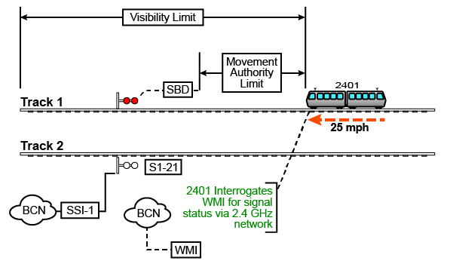

**Overspeed Enforcement with ATP Overlay Configuration**

The carborne controller monitors the wheel encoder interface. If the train exceeds a configurable speed threshold, the carborne controller displays a warning countdown on the train operator display. If required, the carborne controller activates an emergency brake application.

**Overspeed Enforcement with ATP or ATO Configuration**

To ensure safe speeds are maintained, the carborne controller ranges to UWB anchors along the right-of-way and uses that data along with the track map database to determine the location and speed of the train. If the train is traveling above the configurable speed limit for a specific section of track, as defined by the track map database, the carborne controller displays a warning message or activates the service or emergency brake, depending on the railroad’s operating rules. The system supports configurable combinations of warning messages, revocable service brake activations, and non-revocable emergency brake activation for overspeed protection. Overspeed enforcement functionality can also be used to enforce temporary speed restrictions.

**Improperly Lined Switch Protection with ATP or ATO Configuration**

To verify switch status, the carborne controller ranges to UWB anchors along the right-of-way and uses that data along with the track map database to determine the location and speed of the train. At a configurable distance from a switch, the carborne controller interrogates the WMI to obtain the switch status. The route was either previously programmed into the carborne controller by the operator or automatically set by the ATS. The carborne controller performs vital processing to verify that the switch is lined correctly for the route. If the switch is improperly lined, the carborne controller displays a warning message on the train operator display and calculates a SBD using an agency-approved safe braking model. If necessary, the carborne controller activates the emergency brake to prevent the train from traversing the improperly lined switch.

**Train-to-Train Collision Avoidance with ATP Overlay Configuration**

The 2.4 GHz radio make a train-to-train connection, and the UWB radio on each train makes ranging measurements between the front of one train and the rear of another. If the closure rate and distance between the trains exceed the configurable thresholds, the carborne controller displays a warning countdown on the train operator display If required, the carborne controller activates an emergency brake application.

This method of train-to-train protection requires a line of sight between the carborne systems. This requirement and the limitations of UWB ranging, restricts the application of this type of protection to low speeds (usually 25 mph or less, depending on vehicle type). The speed and distance thresholds for train-to-train collision avoidance are configurable per individual railroad requirements.

The illustration below shows train-to-train collision avoidance using an ATP overlay configuration.

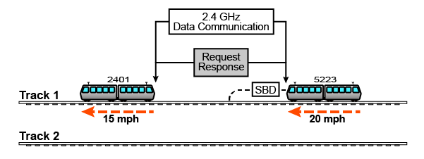

**Train-to-Train Collision Avoidance with ATP or ATO Configuration**

To prevent train collisions, as the train travels down the track, the carborne controller ranges to UWB anchors along the right of way and uses that data with the track map database to determine the location and speed of the train. At a configurable distance from an interlocking at the entrance to the next block, the carborne controller interrogates the WMI to obtain the interlocking status. The WMI responds with the interlocking status and the track occupancy list (TOL), which is a list of all trains in the next block and their status. If all the trains in the block and the train entering the block all have the status “UWB Equipped,” the interlocking allows the train into the block with protection provided by the AURA System. The carborne controller uses the TOL to determine which train is ahead and makes a data connection to that train via the BCN to request the train’s position. The train ahead responds with its location, and the carborne controller uses that information with its own UWB anchor ranging information to calculate a movement authority limit based on an agency-approved safe braking distance model. The carborne controller regularly updates the movement authority limit calculation as the two trains travel down the track.

In the illustration below, for an ATP configuration, Trains 1107 and 2401 use a carborne track database and UWB ranging to UWB anchors to determine their individual location and speed. When Train 2401 reaches a configurable approach threshold to interlocking J1-521, the carborne track map triggers the carborne controller to interrogate the WMI.

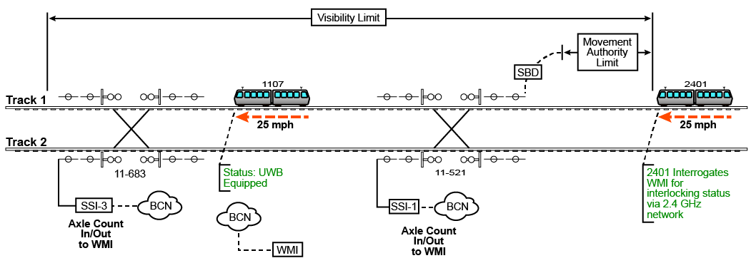

The WMI responds with vital information (Track Asset List and Track Occupancy List). WMI updates UWB status of SSI-1 interlocking to “all trains in the block are UWB–equipped.” SSI-1 activates the moving block interlocking rules.

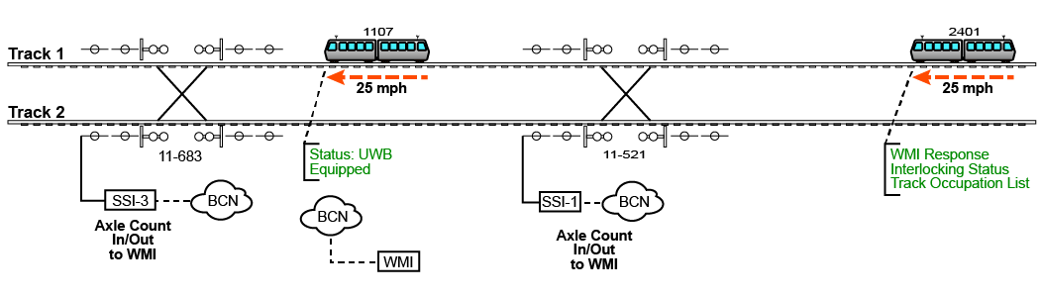

Train 2401 makes a data connection to Train 1107 and requests location information. Train 1107 responds with a vital location message. Train 2401 performs vital processing to use data from Train 1107, including UWB anchor ranging and WMI vital messages to update the visibility limit (VL), SBD, and movement authority limit (MAL). Train 2401 enters the block and continues to perform vital processing to ensure safe train movement.

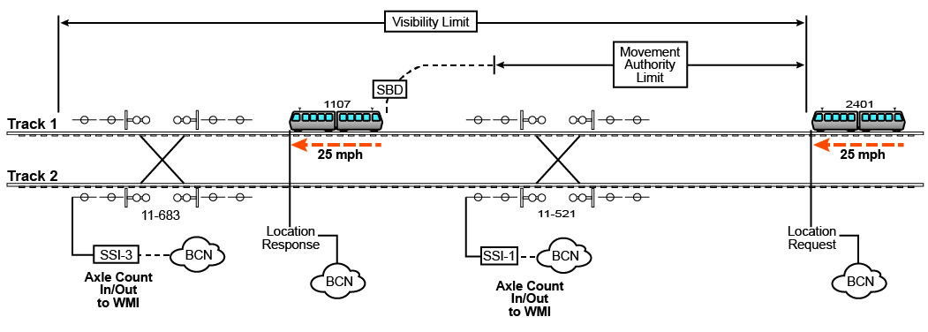

**Automatic Train Operation (ATO)**

When the AURA System is equipped with ATO, either through the addition of the ATO option to the ATP configuration or through the ATO configuration, train routes and schedules are managed by the Automatic Train Supervisor (ATS). Routes and schedules are automatically downloaded to individual train carborne controllers by the BCN. The carborne controller enables ATO mode when all vital conditions have been satisfied. The operator activates ATO mode to drive the train per the ATS route and schedule.

**Installation Advantages**

The installation of the AURA system has a number of advantages over conventional systems when installed on an existing line. The train-centric architecture and scalable design allow the system to be installed in a much shorter time period than conventional systems. The carborne equipment can be installed in 40 to 120 hours per control cab, depending on the vehicle type. The wayside UWB anchors can be installed and tested individually, greatly reducing system acceptance time. Once a number of trains are equipped and a number of anchors are installed, testing of sections of track can be performed in shadow mode without affecting normal railroad operations to gather performance data for system integration to the railroad’s other systems. In this way, sequential testing phases can be performed as installation work is completed, greatly reducing the time, cost, complexity and risk of the system installation.

**Transmission Security**

UWB signals are difficult to detect by design. Regulatory agencies have limited transmit power due to the large bandwidths that UWB occupies. Due to these agency limits, UWB signals only about 50 microwatts in most cases. In addition, impulse UWB pulses are very short, shorter than most RF receiving equipment can detect. Furthermore, the transmissions are pseudo-randomly encoded and modulated so that the signal appears noise-like and is spread evenly over approximately 1 to 2 GHz of bandwidth.

This noise-like signal appearance offers several advantages. First, it is unlikely that transmissions will interfere with other UWB or non-UWB devices. Second, these transmissions are difficult for others to detect, especially at a distance. Third, the pseudo-random behavior makes it difficult to reassemble the information which is transmitted if one doesn’t know the encoding sequence. As a result, these UWB transmissions enjoy low probability of intercept and low probability of detection characteristics.

To coherently integrate each pulse, one must know the quantity of pulses in a packet and the precise timing sequence of those pulses. For additional security, an encrypted security word can be included in the ranging transaction. The value of this word varies according to a proprietary formula.

In addition to the low power and pseudo-random nature of the signal, and encryption, additional factors make it unlikely for someone to create a forgery and successfully complete a ranging transaction. Received waveforms are analyzed by the UWB system for integrity and messages are encoded similarly to spread-spectrum transmissions. Additionally, successful ranging depends on a clock with picoseconds of accuracy to synchronize two asynchronous systems.

The UWB ranging transaction cycle requires the following factors to take place to complete successfully, thereby ensuring that the system is operating properly:

* Both sides must acquire the asynchronous transmission.
* Both sides must successfully track the entire transmission of thousands of pulses.
* Both sides must synchronize timing with picosecond accuracy.
* Both sides must calculate the proper check sum and have no bit errors.

**Safety Strategy**

**Compliance with EN and SIL4 Standards**

The AURA System in the ATP overlay configuration is a non-vital system intended to provide a level of protection that is not defined by CENELEC standards. This system configuration is designed with failsafe, fault tolerant, high reliability, and high availability design principles. This system configuration shares many of the same hardware components as the vital system configurations of the AURA train control system. The safety functions of the system can be certified to a Safety Integration Level (SIL) for specific applications when correctly integrated, and installed and maintained into a railroad’s vital signaling system. SIL design principles and controls are applied to both the overlay system and the vital signaling system to implement a SIL for the combined system.

**Applicable Standards**

The AURA System complies with the following safety standards:

* CENELEC EN50126, EN50128, EN50129
* AREMA C&S Manual section 17
* IEEE 1698
* IEEE 1558

**Safety Level**

The safety functions of the AURA System in the ATP and ATO system configurations are designed to exceed the safety integrity requirements needed to meet EN50128/129 SIL4 when correctly installed, integrated, and maintained for a specific application.

**Technical Specifications**

**Environmental Specifications**

**Temperature, Humidity, Shock, and Vibration Specifications**

|  |  |
| --- | --- |
| **Equipment Location** | **Specification** |
| Carborne Cab Equipment | AREMA 2019 Part 11.5.1 Class J |
| Carborne External Equipment | AREMA 2019 Part 11.5.1 Class H |
| Wayside Enclosure | AREMA 2019 Part 11.5.1 Class C |
| Control Center | AREMA 2019 Part 11.5.1 Class E |

**ESD/EMI/EMC Specifications**

|  |  |
| --- | --- |
| **Test** | **Specification** |
| ESD | IEC 61000-4-2:2008 (Level 3) |
| EMC | SAE J1113/11 (24v System)  IEC 61000-4-3:2010 |
| EMI  FCC/IC Services | CISPR 22:2008 Edition 6.0  IEC 61000-4-6:2008  FCC Title 47, Part15, Subpart B for Class A  Industry Canada ICES-003 for Class A |

**Abrasive Environment Specifications**

|  |  |
| --- | --- |
| **Test** | **Specification (externally mounted equipment only)** |
| Salt Spray | MIL-STD-810, Specification Method 509.5 |
| Icing | NEMA 250-2008, Section 5.6 |
| Hose Down | NEMA 250-2008, 4X, Section 5.7 |

**System Characteristics**

|  |  |  |  |
| --- | --- | --- | --- |
| **Description** | **Parameter** | **Description** | **Parameter** |
| Carborne Controller power | 4.5-6.0 A @ 24 VDC | UWB Anchor Module power | 0.4-0.5 A @ 24 VDC |
| Wayside Message Interface power | 4.5-6.0 A @ 24 VDC | Network requirements  (if applicable) | All ethernet connections require 10/100Base-T/TX, RJ45 or higher. |
| CC localization accuracy | +/- 0.25 m (minimum) | CC speed accuracy | +/- 3 kph |
| Zero speed detection | <1 kph/h for 2 s |  |  |

**Definitions and Abbreviations**

|  |  |
| --- | --- |
| ATO | Automatic Train Operation |
| ATP | Automatic Train Protection |
| ATS | Automatic Train Supervisor |
| BCN | Backbone Communication Network |
| CAS | Collision Avoidance System |
| CBTC | Communications-Based Train Control |
| CC | Carborne Controller |
| EOL | End-of-Line |
| MAL | Movement Authority Limit |
| RF | Radio Frequency |
| RFID | Radio-frequency identification |
| RWPS | Roadway Worker Protection System |
| SBD | Safe Braking Distance |
| TAL | Track Asset List |
| TOD | Train Operator Display—A smart display screen located in each control cab connected to the CC by the onboard Ethernet network. The TOD displays various information sets depending on the operating mode. |
| TOF | Time of Flight |
| TOL | Track Occupancy List |
| UAM | Ultra-Wide Band Anchor Module—A compact redundant UWB radio transceiver that the CC radio ranges to in order to localize the train position. Each UAM contains redundant UWB radios. UAMs are located at fixed positions along the right of way so that the CC is always in contact with two UAMs for redundancy. |
| UDS | UAM Diagnostic Server—A rackmount server that performs diagnostic testing of UWB anchors for fault identification and predictive maintenance. A modular and redundant vital processing unit with various interfaces to onboard systems (door control, service brake, emergency brake, and propulsion) |
| UWB | Ultra-Wide Band |
| VL | Visibility Limit |
| VML | Vital Message List |
| WMI | Wayside Message Interface |